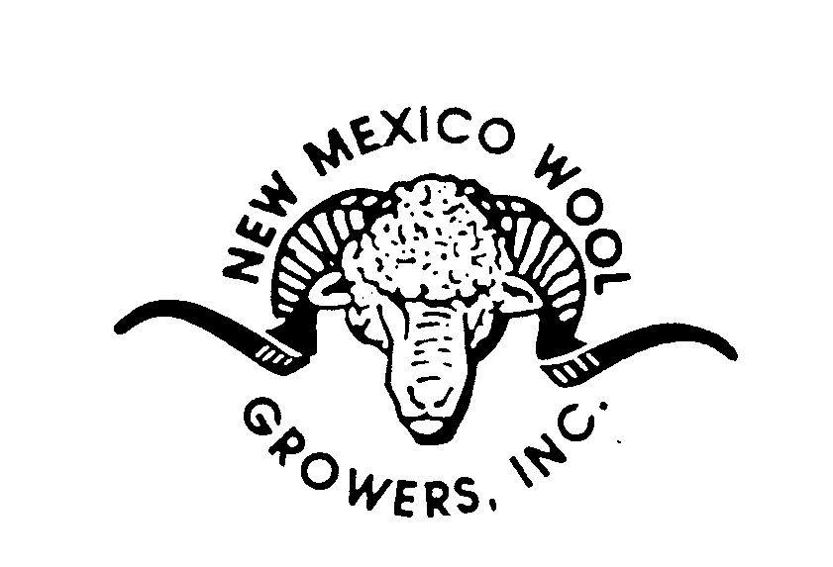
New Mexico Wool Growers, Inc.
Sustainable Agriculture Protecting the Environment & All Its Creatures

You Are Invited

NMWGI Wool Educational Field Day

Date: January 29, 2025

Venue: Commercial Building Eastern New Mexico State Fair Grounds

Participants: FFA Chapters with individuals enrolled in wool judging and sheep production

Event: The Wool Educational Field Day enhance an FFA member’s knowledge and ability to determine the grade, rank, and categorize wool. The Field Day will provide an opportunity for youth to develop skills that can be used in a judging contest and on a sheep ranching operation, within the wool industry, or agricultural teaching field.

The day will include presentations and small group work with hands on opportunities and time to share ideas and experiences

- Presentations will include:
  - Grade
  - Fiber Diameter and Grade
  - Fleece Weight and Yield
  - Staple Length and Strength
  - Other Characteristics to consider

- Activities: Build you own “Wool Kit”
  - Each FFA Chapter will have the opportunity to build their own “Wool Kits”
    - Kits will include
      - Wool samples
      - Fleece descriptions

If you are interested in participating please email the below application to nmcga20@gmail.com by January 10, 2025.

P.O. Box 2822 Moriarty, NM 87035 / 809 First Street
Phone: (505) 250-1165 Fax: (505) 842-1766

NMWGI Wool Educational Field Day
Registration Form

DEADLINE January 10, 2025

Name of Chapter: ___________________________________

Name of Contact: ____________________________________

Address: __________________________________________

City: _________________ State: ___________ Zip:________

Phone: ____________________

Email: ___________________________________________

Number of Students Attending: __________

Name of Students Attending:

________________________________________________

________________________________________________

________________________________________________

________________________________________________

________________________________________________

________________________________________________

________________________________________________

________________________________________________

NMWGI Wool Educational Field Day

Schedule/Program

10:00am Arrival / Registration

10:30am Welcome – Mike Corn, Roswell Wool Warehouse

10:45am Wool Industry Overview – Mike Corn

10:15am Wool Judging Presentation – Texas Tech Wool Judging

12:oo noon Lunch

1:00pm Presentations

2:00pm Closing remarks

2:15pm Assemble Wool Kits

2:30pm Students board busses

