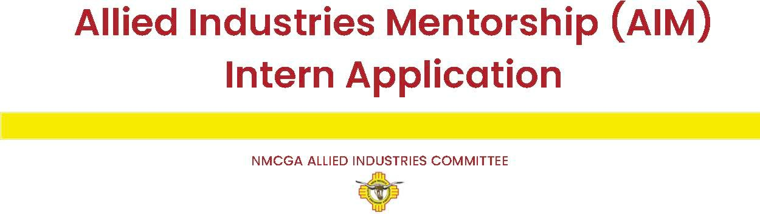

# OPPURTUNITIES FOR RISING INDUSTRY LEADERS

**Name**:

(Last) (First) (MI)

**Address**:

(Street) (City) (ST) (Zip)

**Phone**: **Email**:

What College/University do you attend?

What is your major?

Degree Level: Graduation month/year:

***Please respond to the questions below:***

What is your short-, mid- and long-term goal for your degree? (300 Words or less)

What do you hope to learn or gain by attending the 2025 Joint Stockmen’s Convention? (300 Words or less)

ALLIED INDUSTRIES MENTORSHIP INTERN APPLICATION

How will attending the 2025 Joint Stockmen’s Convention assist you in furthering your academic and/or professional career? (300 Words or less)

What career paths are you interested in pursuing after graduation? (300 Words or less)

Please share some of your awards, achievements, hobbies, or organizational leadership/participation.

# Please include a short bio about yourself below. (500 words or less)

**\*\*\*\*\*Email completed application and a quality headshot to** [**nmcga20@gmail.com**](mailto:nmcga20@gmail.com) **by October 15, 2025.**